Customer Churn Prediction in Vietnam's Enterprise Market Using Machine Learning Methods in a Streaming Data
NGUYEN-HOANG Anh-Tuan  Nam Can Tho University  Can Tho, Vietnam | TRAN Binh-An  Adhightech Ltd.  Can Tho, Viet Nam | NGUYEN Anh-Duy  Adhightech Ltd.  Can Tho, Viet Nam  nguyenanhduy@adhigtechn.com

Abstract—Customer churn prediction has become a crucial challenge for enterprises, particularly in rapidly changing markets. In Vietnam, where the economy is gradually stabilizing and expanding after a period of turbulence, businesses must adapt to dynamic market conditions to ensure sustainable growth. Artificial intelligence (AI), and more specifically machine learning (ML), provides powerful tools to address this challenge by enabling accurate forecasting of customer attrition. This study focuses on developing machine learning models combined with the Evolving with Klinkenberg's Idea (EKI) technique to handle evolving datasets and deliver real-time churn prediction. Seven algorithms EKI-ExtraTree, EKI-Bagging, EKI-RandomForest, EKI-Decision Tree, EKI-MLP (Multilayer Perceptron), EKI-GaussianNB were implemented under the EKI framework. Experimental results show that the EKI-Decision Tree model achieved the best performance with a 99% balanced accuracy, highlighting its robustness in streaming data environments. Although the current experiments rely on international datasets, the continuous learning mechanism ensures adaptability, allowing the framework to gradually incorporate data collected from Vietnam in the future, thereby forming a localized dataset tailored to the domestic enterprise market. The findings emphasize the role of EKI-enhanced machine learning as a vital component in strengthening customer relationship management and proactive retention strategies.
Keywords—Customer Churn, Churn Prediction, Machine Learning, Continuous Learning, Dynamic Market.

I. INTRODUCTION
During the past decade particularly in the aftermath of the pandemic and the cost-of-living crisis the global economic landscape has experienced significant volatility. As recovery gradually unfolds, service-based business models have expanded rapidly, with subscription-driven offerings becoming a dominant trend. Yet, this rapid proliferation has increasingly placed consumers in a state of “subscription fatigue,” characterized by feelings of overload and frustration stemming from the need to simultaneously manage and pay for numerous recurring service plans (Juliane Waack, 2025). This situation not only generates financial and psychological strain but also hinders users from extracting the full value of the services they subscribe to (DigitalRoute, 2025). Consequently, churn rates have escalated, most notably within the subscription video on demand (SVOD) market, where the average cancellation rate approached 47\% in 2023 (David Satin, 2023).
Customer Churn Rate refers to the proportion of users who discontinue a product or service within a defined time period (Lan M., 2019). Customer attrition has long been recognized as a central challenge across industries, primarily because maintaining existing customers is substantially more cost-efficient than acquiring new ones. This issue is further amplified by estimates indicating that recruiting a new customer can cost between five and twenty-five times more than retaining a current one. Additionally, empirical findings reveal that even a 5\% increase in customer retention can elevate profits by 25\% to 95\% (Amy Gallo, 2014). Telecommunications is consistently identified as the sector exhibiting the highest churn levels, with annual rates ranging from 20\% to 40\% (MP Transformation, 2025). The contributing factors include intense competition among service providers, the continuous introduction of attractive pricing packages, and service quality that often fails to meet user expectations. The context in Vietnam reflects this pattern: from 2018 to 2024, more than 2.3 million subscribers migrated to Viettel under the “mobile number portability” initiative (Ha Linh, 2024). Importantly, even marginal improvements in customer retention can yield notable financial gains for businesses. These statistics underscore that churn does not merely represent the departure of a segment of users; it directly translates into reduced revenue, increased marketing expenditures, and weakened competitive positioning. In the context of ongoing global economic instability, strengthening customer loyalty has become an essential priority for businesses across all sectors. Advances in digital technologies particularly Big Data and Artificial Intelligence (AI) have introduced new methodologies for analyzing and forecasting consumer behavior. As a core component of AI, machine learning facilitates the processing of large-scale datasets, the extraction of subtle behavioral patterns, and the prediction of churn before it takes place. These capabilities support early warning mechanisms while also enabling the design of personalized intervention strategies, the optimization of retention-related expenditures, and the enhancement of overall user experience. Recent statistics indicate that as many as 75\% of customers are willing to switch to another brand when faced with unsatisfactory or unresolved experiences. This trend demonstrates that the risk of churn is no longer concentrated solely in highly competitive fields such as banking but is expanding across diverse business domains. Elevated churn levels not only diminish earnings but also jeopardize long-term growth. Consequently, the development of churn prediction models based on machine learning holds significant practical value, offering a data-driven foundation for identifying at-risk user groups and informing the creation of more effective retention strategies.
To deliver a solution applicable in real-world contexts, this project is structured around two key objectives: (i) developing an online platform that allows users to interact directly with prediction outputs and promptly design customer care strategies guided by system recommendations, and (ii) establishing a bridge between academic research and practical deployment to help organizations efficiently convert data into actionable insights. Building on this foundation, the research team performs analysis, experimentation, and comparison of machine-learning models enhanced through the EKI (Evolving with Klinkenberg's Idea) approach (Anh-Khoi, N. H. et al., 2024a; Trieu, V. K. et al., 2023), including EKI-ExtraTree, EKI-Bagging, EKI-RandomForest, EKI-Decision Tree, EKI-MLP (Multilayer Perceptron), and EKI-GaussianNB. A notable strength of these methods lies in their ability to (iii) continuously update and dynamically adjust internal parameters, thereby sustaining adaptability when faced with evolving real-world data. The research process begins with the use of international datasets and is subsequently refined by (iv) tuning variables to align more closely with the characteristics of Vietnamese data, with the overarching goal of identifying the most effective solution for addressing customer churn.

II. RELATED WORK
Customer churn remains one of the most pressing challenges for modern enterprises, as it has a direct impact on revenue streams, profit margins, and long-term growth prospects. In an environment marked by intense market competition and rapidly shifting consumer behavior, the development of effective churn prediction models requires datasets that are sufficiently extensive, representative, and reliable. During the investigation of publicly accessible data sources, a total of 402 churn-related datasets were identified on the Kaggle platform. However, most were unsuitable for research purposes due to missing information or a substantial proportion of incomplete values, limiting their applicability in model development. Following a thorough filtering process, only three datasets were deemed appropriate for experimentation.
The first dataset, titled “Customer Churn Dataset” and provided by Muhammad Shahid Azeem (Muhammad S. A., 2023), is the largest and most comprehensive dataset employed in this study. It comprises two files a training set containing 440,882 records and a test set containing 64,374 records resulting in a total of 514,373 entries with 12 attributes. These attributes encompass demographic characteristics, service usage patterns, contract information, and the churn label. The dataset's substantial scale enables machine learning models to capture diverse behavioral patterns, thereby mitigating overfitting risks and improving generalization capability. Its breadth also makes it suitable for a variety of algorithmic approaches, ranging from traditional techniques to deep learning models, while ensuring greater reliability in performance assessment. The second dataset, contributed by Anand Shaw and titled “Churn_Modelling.csv (684.86 kB)” (Anand Shaw, 2024), contains 10,002 records with 14 attributes. It was designed to reflect churn-related behaviors across different business domains, particularly within the banking industry. The dataset includes detailed demographic information (such as age, gender, and nationality), account-related data (including balance, number of active products, and credit score), and the churn label. With its moderate size, the dataset is well suited for evaluating medium-complexity algorithms and examining correlations between financial behavior and churn likelihood. The third dataset, provided by Ahmed Gaitani and titled “customer_churn_prediction_dataset.csv (43.89 kB)” (Ahmed Gaitani, 2024), is the smallest among the selected datasets, consisting of 300 records and 12 attributes. Focused primarily on the telecommunications sector, it contains demographic information, contract details, and indicators of service usage. Despite its modest scale, the dataset is valuable for rapid experimentation or as a demonstrative example of how churn prediction models can be formulated and implemented. It also serves as a basis for comparing the performance of models trained on small-scale versus large-scale datasets. Among the three datasets, the dataset provided by Muhammad Shahid Azeem was selected for subsequent experimentation due to its substantial size, detailed attributes, adaptability across various modeling techniques, and, most notably, its capacity to ensure that the experimental findings remain both robust and applicable in practice. The dataset “customer_churn_dataset-training-master.csv” contains the features and descriptions summarized in Table 1.
TABLE I
DATASET FEATURES AND DESCRIPTIONS
Feature | Type | Description
CustomerID | Identifier | Unique customer ID, used for tracking and train-test split; excluded from prediction.
Age | Numerical | Customer age; nonlinear relation with churn; may require grouping/normalization.
Gender | Categorical | Gender; encoded (one-hot/target); consider fairness and “other/undisclosed” category.
Tenure | Numerical | Subscription length; inversely related to churn; log transform/segmentation suggested.
Usage Frequency | Numerical | Frequency of service usage; skewed distribution; derived features (trend, variability).
Support Calls | Numerical | Number of support contacts; U-shaped relation; separate by issue if available.
Payment Delay | Numerical/Cat. | Payment delays; categorized (0, 1–7, 8–30, >30 days); indicates financial risk.
Subscription Type | Categorical | Package/plan type; encode ordinally or by economic features (price, ARPU).
Contract Length | Numerical | Contract duration; transform to “time to expiration” or contract status flag.
Total Spend | Numerical | Total expenditure; heavy-tailed; normalize by time (e.g., ARPU) to reduce correlation.
Last Interaction | Timestamp | Most recent customer interaction; convert to Recency; avoid leakage.
Churn (Class) | Target (Binary) | Outcome variable (1 = churn, 0 = not churn); requires consistent definition.

During this study, noisy data were addressed using Multiple Imputation (MI), a widely adopted technique for handling Missing Values (Austin, P. C. et al., 2021). The proposed algorithm also incorporates an automatic mechanism to detect the output class and standardize its label as Class (in this study, Class = Churn). A key challenge in developing churn prediction models arises from the fact that most existing training datasets originate from international sources. Although certain similarities exist between consumer behaviors in Vietnam and other countries, notable differences remain in terms of demographic structure, spending patterns, and service usage behaviors. Consequently, directly applying global datasets to the Vietnamese context often results in suboptimal predictive effectiveness.Constructing a new, large-scale customer dataset specifically tailored to Vietnam would require substantial financial investment, significant human resources, and a lengthy timeline that could span many years. The extensive collection of customer behavior data, transaction histories, and service retention information presents both logistical and technical constraints that are impractical under current conditions. To mitigate these limitations, an incremental and feasible strategy involves leveraging global datasets as an initial foundation and progressively adapting models to domestic data through continuous learning. This approach shortens deployment time while ensuring that the resulting predictive systems remain scalable and capable of accommodating churn-related characteristics within Vietnam. Through continuous learning, models can be initialized using international datasets and iteratively refined as local customer data becomes available. This adaptive process referred to as concept drift adjusts the initial conceptual space derived from global data so that it better captures the behavioral and economic attributes unique to the Vietnamese market. As a result, the predictive system can be deployed immediately with acceptable accuracy and subsequently improved over time.A fundamental limitation of traditional machine learning is the static nature of data storage, where datasets remain fixed and do not update automatically. Therefore, when new data arrives, the model typically requires full retraining a resource-intensive process that is unsuitable for dynamic, real-world environments. In many cases, existing data may already support initial prediction tasks, whereas additional real-world behavioral data may not yet be fully captured. Continuous learning offers an effective solution by enabling incremental model updates that incorporate newly available data, eliminating the need to wait for a complete dataset before retraining. The increasing demand for models capable of updating alongside real-time data has driven substantial advancements in incremental and evolving learning techniques. Among the foundational approaches is the sliding window method, which maintains a fixed-size data window, denoted as s, determined by either the number of samples or a specified time interval. With each update cycle, the window shifts forward to include new data while removing outdated samples, thereby producing a refreshed training set. The model at time t is reconstructed based on this updated dataset, allowing it to reflect current data stream characteristics. Overlapping windows, denoted as w, help reduce information loss and maintain continuity during the learning process (Raab Christoph et al., 2020). The effectiveness of this method is significantly influenced by the selection of an optimal window size, which determines the model's ability to process streaming data. Recent studies have introduced automated techniques for determining window size using accuracy-based criteria (Lazarescu M. et al., 2003; Last M., 2002). This study centers on applying Klinkenberg's method for identifying the optimal window size s across classical learning tasks (Klinkenberg R., 2004). This approach enables the regulation of information loss by adjusting training sample density within the selected window. Incorporating Klinkenberg's concept reduces the need for multiple hyperparameters, requiring only a single parameter n to determine batch size and thereby minimizing information loss during generalization a common issue in evolving learning frameworks. Building on this foundation, the EKI (Evolving with Klinkenberg's Idea) framework (Ngo-Ho Anh-Khoi et al., 2024b) is implemented, integrating several algorithms: EKI-ExtraTree, EKI-Bagging, EKI-RandomForest, EKI-Decision Tree, EKI-MLP (Multilayer Perceptron), and EKI-GaussianNB. By combining Klinkenberg's methodology with sliding window mechanisms, these algorithms evolve from traditional static models into systems capable of continuous learning, making them suitable for dynamic datasets and real-time prediction scenarios. In recent research, Balanced Accuracy (BA) has been recognized as a robust metric for model evaluation, particularly in cases involving imbalanced datasets (Ho et al., 2013, 2016, 2017). BA is computed as the average of Sensitivity and Specificity, providing a balanced assessment that reflects both correctly predicted positive cases and correctly predicted negative cases. This metric helps mitigate bias when class distributions are significantly uneven and is applicable to both agreement and disagreement detection tasks (Powers, D. M., 2020; Ho, N., \& Khoi, A., 2015). However, several widely used metrics such as Sensitivity, F-Score, and even conventional BA have been criticized for overlooking the “true negative” component of the confusion matrix. Excluding this component can introduce bias and weaken model reliability in practical deployment settings. In disagreement detection settings, Specificity is sometimes emphasized, albeit less frequently, whereas agreement detection tasks tend to rely more heavily on BA, Sensitivity, and F-Score. This limitation becomes particularly pronounced in severely imbalanced datasets. For example, in a test set of 100 instances with a class ratio of 90:10, a model that predicts all instances as belonging to the majority class may achieve a deceptively high traditional Accuracy score. However, such a result lacks practical value, as it fails to capture the model's true classification capabilities. Therefore, in practice, when working with datasets exhibiting substantial class imbalance, evaluation measures such as AUC, BA, or combinations with F-Score are generally preferred over relying solely on Accuracy. The formula for Balanced Accuracy (BA), which provides a practical and optimal evaluation, is:
Balanced Accuracy (BA) = ½ (Specificity + Sensitivity) (1)

III. EXPERIMENT AND DISCUSSION
In this study, the dataset comprises more than 514,000 records, which the original author had pre divided into two subsets: a training set with 440,882 records and a test set with 64,374 records. The entire training set was employed to implement batch online learning, corresponding to an initial 440,882 training steps. These steps were subsequently partitioned into 100 smaller batches, each containing approximately 4,409 records, thereby ensuring a more stable and detailed learning process. Additionally, the data were continuously shuffled after each training iteration to maintain objectivity and enhance the reliability of the results.
Based on the comparative results illustrated in the chart, the seven evaluated algorithms display varying degrees of performance in terms of Average accuracy and the Last Batch score. Among them, EKI-Decision Tree stands out with an exceptional level of consistency, reaching 99.39\% on average and improving further to 99.63\% in the final iteration. This slight upward shift indicates that the model maintains strong predictive capability while continuing to refine its performance toward the end of training. Although EKI-Bagging and EKI-RandomForest also achieve high accuracy, EKI-Decision Tree demonstrates a more uniform and reliable trend across both criteria. With the current evidence, it is reasonable to consider EKI-Decision Tree as the best-performing algorithm in this comparison (see Figure 1).
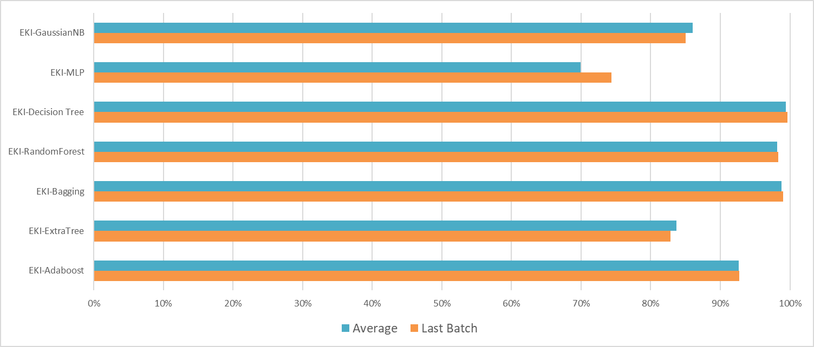
Fig. 1. Comparison of Algorithms Based on Average Accuracy, and Last Batch Performance
Examining the three complementary metrics available in the new dataset Average accuracy, Last Batch accuracy, and Standard Deviation provides a more nuanced picture of model behavior across training. Average accuracy captures the model's overall performance across runs, Last Batch reflects the final converged performance that would be deployed, and Standard Deviation quantifies sensitivity to variation between evaluations (i.e., reliability). In this comparison, EKI-Decision Tree leads across the board: it posts an Average of 99.39\% and improves to 99.63\% on the Last Batch, while maintaining a modest SD = 0.64\%. This combination indicates both top-tier predictive power and low variability traits that are highly desirable when deploying models in production. EKI-Bagging shows nearly equivalent accuracy (Average = 98.82\%, Last = 99.05\%) with slightly higher variability (SD = 0.93\%), suggesting it is an excellent choice when raw accuracy is the principal objective, though marginally less consistent than Decision Tree. EKI-RandomForest (Average = 98.16\%, Last = 98.31\%, SD = 0.56\%) trades a small portion of accuracy for slightly better stability, making it attractive for scenarios prioritizing long-term robustness. At the other end, EKI-MLP exhibits large variance (SD = 5.83\%) despite a Last Batch uptick, implying unpredictable performance across runs and higher deployment risk. EKI-ExtraTree shows both a drop from Average to Last Batch (83.67\% 82.85\%) and a relatively high SD (2.46\%), signaling sensitivity to data fluctuations. EKI-Adaboost maintains a low SD (0.37\%) but lower average accuracy (92.67\%), which positions it as a stable but less powerful predictor. EKI-GaussianNB performs modestly (Average 85.99\%, Last 84.99\%) with moderate variability (SD = 0.80\%). Considering all three metrics together, EKI-Decision Tree is the top candidate due to its superior accuracy and acceptable stability. EKI-Bagging and EKI-RandomForest are close contenders Bagging slightly favors peak accuracy while RandomForest offers marginally better steadiness. EKI-Adaboost is the most consistent but noticeably less accurate; EKI-ExtraTree and EKI-MLP are less suitable for high-stakes predictive tasks given their instability or lower mean performance. (see Table 1).
TABLE II
AVERAGE OF BALANCED ACCURACY, BALANCED ACCURACY OF THE LAST BATCH AND STANDARD DEVIATION OF THE EKI ALGORITHMS
EKI Algorithms | Average (%) | Last Batch (%) | Standard Deviation (%)
EKI-Adaboost | 92.75 | 0.37 | 92.67
EKI-ExtraTree | 82.85 | 2.46 | 83.67
EKI-Bagging | 99.05 | 0.93 | 98.82
EKI-RandomForest | 98.31 | 0.56 | 98.16
EKI-Decision Tree | 99.63 | 0.64 | 99.39
EKI-MLP | 74.40 | 5.83 | 69.95
EKI-GaussianNB | 84.99 | 0.80 | 85.99

In this study, we evaluated seven algorithms from the EKI family, including EKI-Adaboost, EKI-ExtraTree, EKI-Bagging, EKI-RandomForest, EKI-Decision Tree, EKI-MLP, and EKI-GaussianNB. Instead of focusing solely on average accuracy values, the evaluation methodology was designed around the progression of balanced accuracy according to the number of learning batches (``n''), allowing us to observe each model's improvement capability, stability, and convergence behavior over time. The results show that EKI-Bagging is the most stable and consistently performing algorithm. Its performance curve remains at a high level with minimal fluctuation throughout the training process, reflecting strong generalization ability and reliability when deployed in practical environments. While EKI-RandomForest also achieves high accuracy, its greater fluctuations indicate lower stability compared to Bagging. EKI-Adaboost maintains relatively good stability but only achieves moderate accuracy, which limits its suitability for high-performance prediction systems. In contrast, EKI-ExtraTree and EKI-Decision Tree exhibit significant volatility during evaluation, indicating high sensitivity to data variation and a lack of stability. EKI-MLP shows improvement over time but experiences considerable noise across training cycles, whereas EKI-GaussianNB yields the lowest performance and does not show a clear upward trend. Based on these findings, the three most promising algorithms are EKI-Bagging, EKI-RandomForest, and EKI-Adaboost. The following in-depth analysis will focus on these three models to determine the most appropriate solution for the predictive system in this experimental study.
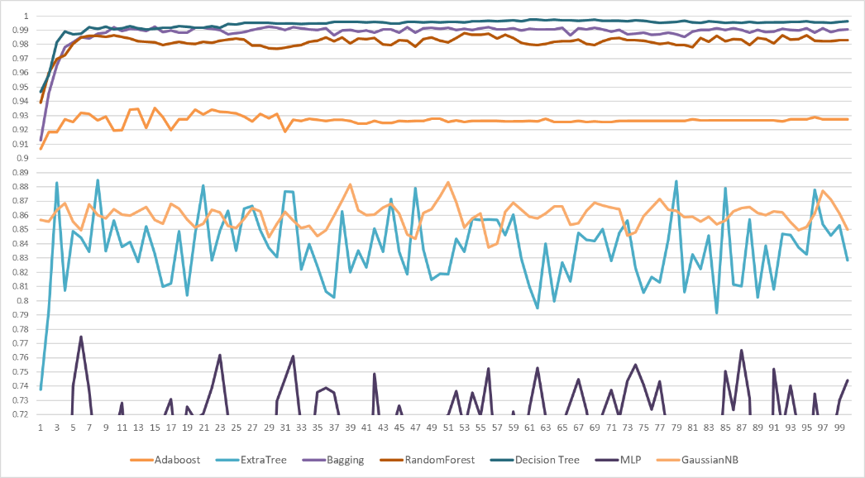
Fig. 2. Progression chart of balanced accuracy of the 7 EKI algorithms
Following the comparative evaluation across seven EKI-based algorithms, a deeper analysis was conducted focusing on both performance stability and balanced-accuracy progression across learning batches. The results derived from the experimental curves and summary statistics collectively highlight three algorithms that consistently outperform the others: EKI-Decision Tree, EKI-Bagging, and EKI-RandomForest. Among them, EKI-Decision Tree achieved the highest final balanced accuracy (99.63\%), accompanied by a low standard deviation, confirming its strong reliability across iterations. EKI-Bagging demonstrated excellent performance, maintaining accuracy around 99\% with minimal fluctuation, reflecting a robust generalization capability. Meanwhile, EKI-RandomForest offered a competitive accuracy level (98.31\%) and exhibited the highest stability among the top three, evidenced by the lowest standard deviation in this group. The convergence patterns illustrated in the balanced-accuracy progression chart further reinforce these findings. All three algorithms exhibit early stabilization and sustained high performance, making them suitable candidates for environments requiring dependable predictive behavior across sequential learning stages.
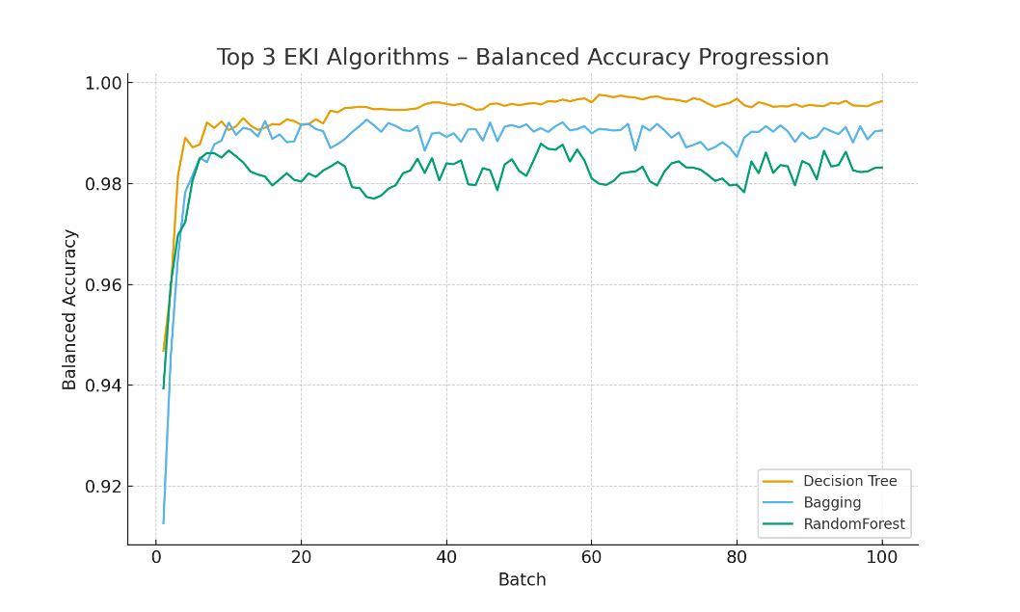
Fig. 3. Top 3 EKI Algorithms
From these analyses, it can be concluded that EKI-Decision Tree outperforms in both performance and stability. It not only achieves high balanced accuracy but also minimizes fluctuation, making it the optimal choice for applications requiring reliable results (see Figure 3).

IV. CONCLUSION AND RESULT
In the field of customer churn research, establishing a dedicated economic database for Vietnam is both essential and highly challenging. Currently, most predictive models rely on international datasets. Although certain similarities exist in market structures and consumer behaviors, marked differences in demographic composition, spending patterns, economic conditions, and business environments significantly limit the direct transferability of global data to the Vietnamese context. One of the major obstacles lies in the lack of a specialized domestic database, which renders the immediate deployment of a comprehensive churn prediction system nearly impossible. Constructing and standardizing large-scale customer datasets in Vietnam requires extensive human, financial, and temporal resources often stretching across many years or decades. To address this limitation, continuous learning presents a more feasible and cost-effective alternative. Instead of waiting for a fully developed large-scale dataset, the model can be incrementally refined through periodic updates from smaller, localized data streams. This process enables the prediction system to gradually adjust its conceptual structure, transitioning from an international foundation toward a representation increasingly aligned with Vietnam's economic environment. This adaptive process commonly described as concept drift allows the model to enhance its predictive accuracy by continuously incorporating newly available domestic data. As a result, the deployment of a churn prediction system can begin at an early stage, with progressively improved performance rather than postponing implementation until a comprehensive national database emerges. Within this study, the EKI-Decision Tree algorithm is selected as the core solution due to its capacity to adapt to continuous data streams and its demonstrated predictive stability. The proposed system architecture includes core modules such as churn prediction, classical algorithm integration, trained model management, system configuration, and user authentication. The platform is implemented as a web-based application serving two primary user groups: (i) system administrators and developers responsible for configuring and optimizing algorithms, and (ii) business users who leverage prediction outputs to support strategic decision-making activities.
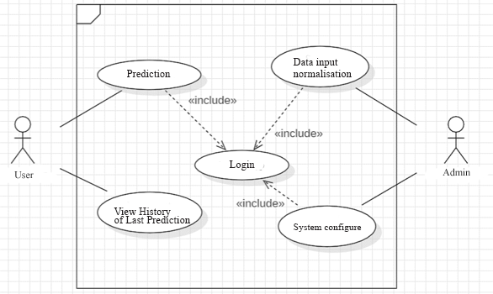
Fig. 4. Use-case diagram of the system
The program package is distributed as setup.zip. After extraction, the directory contains essential components such as: SETUP, DB, APP, INSTALL.bat, RunServer.bat, and requirements.txt. The SETUP folder includes the installer python-3.9.9-amd64.exe, which must be executed before continuing. Library dependencies are installed automatically using LibInstallation.bat. The DB folder stores the database file Data.db. This file can be viewed or modified via the DB Browser for SQLite tool provided in the subfolder DBDB Browser for SQLite. If needed, administrators can erase all existing records and reset the system using Remove.bat. User authentication data, particularly administrator account details, is maintained in APPstaticdataUser.csv, which can be directly modified if account configuration changes are required. To start the application, users can simply double click RunServer.bat or open the command line and type the command manage.py runserver. By default, the system listens on port 8000, but this can easily be changed by appending a custom <port> parameter. When the terminal displays the message “Starting development server at http://127.0.0.1:8000/”, the application's interface becomes accessible through the browser at http://127.0.0.1:8000/(see Figure 5).
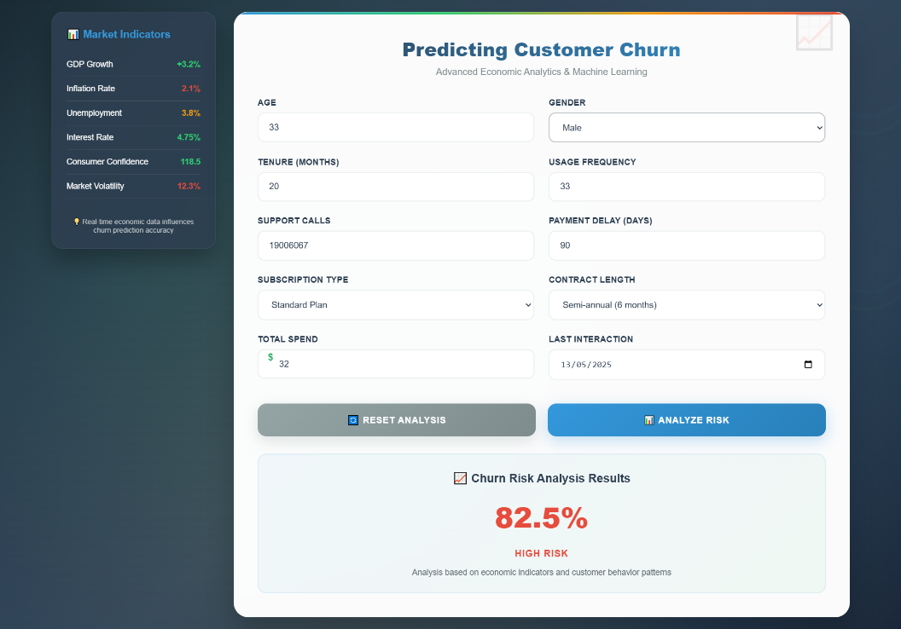
Fig. 5. Main interface of the application
In the economic context, predicting and managing customer churn is increasingly critical because of its direct implications for business growth and profitability. The lack of large-scale standardized datasets in Vietnam continues to hinder the establishment of an immediate and reliable churn prediction system. Building such datasets necessitates substantial investment and long-term commitment. Continuous learning therefore emerges as an effective alternative, enabling incremental model evolution with smaller domestic datasets rather than requiring a complete dataset from the outset. Through this mechanism, models initially trained on international data gradually adapt to Vietnam's business landscape via concept drift, facilitating early deployment while allowing accuracy to improve over time. This study assesses continuous learning algorithms within the EKI framework including EKI-ExtraTree, EKI-Bagging, EKI-RandomForest, EKI-Decision Tree, EKI-MLP, and EKI-GaussianNB. Among these, EKI-Decision Tree exhibits the strongest performance in churn prediction, positioning it as the primary model for this research. The findings underscore its potential to support enterprises in mitigating customer attrition risks and improving strategic decision-making capabilities.

References
- Juliane Waack (2025). Subscription Fatigue: How to stay ahead in the subscription race. https://frisbii.com/blog/subscription-fatigue-convince-customers-competition
- David Satin (2023). Subscription Fatigue Growing as Churn Rate Hits 47%; Price Considerations Most Common Reason. https://thestreamable.com/subscription-fatigue-growing-as-churn-rate-hits-47-percent-price-considerations-most-common-reason
- DigitalRoute (2025). Subscription Fatigue. https://www.digitalroute.com/resources/glossary/subscription-fatigue/
- Amy Gallo (2014).The Value of Keeping the Right Customers. https://hbr.org/2014/10/the-value-of-keeping-the-right-customers
- Lan M. (2019). What is Customer Churn Rate?. https://vietnambiz.vn/ti-le-khach-hang-roi-bo-customer-churn-rate-la-gi-20191121181913287.htm
- Getfly (2023). Doanh nghiep dau dau noi lo khach hang roi bo.https://getflycrm.com/doanh-nghiep-dau-dau-noi-lo-khach-hang-roi-bo/
- Ha Linh (2024). Nha mang nao dang dan dau cuoc dua chuyen mang giu so?.https://www.anninhthudo.vn/nha-mang-nao-dang-dan-dau-cuoc-dua-chuyen-mang-giu-so-post564611.antd
- MP Transformation (2025). Ty le khach hang roi bo. https://mpt.com.vn/ty-le-khach-hang-roi-bo/
- Trieu, V. K., Le, D. T., Luc, H. D. N., & Ngo, H. A. K. (2023). Hotel room booking prediction using k-neighbors classifier method combined with sliding windows. Journal of Science and Development Economics, (33), 31-40.
- Anh-Khoi, N. H., Ha-Duy-Nguyen, L., & Vinh-Khang, T. (2024a). Artificial Intelligence Applied to Address Tourism Challenges: Predicting Hotel Room Cancellations. In 11th International Conference on Emerging Challenges: Smart Business and Digital Economy 2023 (ICECH 2023) (pp. 434-445). Atlantis Press..
- Muhammad S. A. (2023). Customer Churn Dataset. https://www.kaggle.com/datasets/muhammadshahidazeem/customer-churn-dataset
- Ahmed Gaitani (2024). Customer Churn Prediction Dataset. https://www.kaggle.com/datasets/ahmedgaitani/customer-churn-prediction-dataset
- Anand Shaw (2024). Customer Churn Dataset.https://www.kaggle.com/datasets/anandshaw2001/customer-churn-dataset
- Raab Christoph, Heusinger Moritz, Schleif Frank-Michael; Reactive Soft Prototype Computing for Concept Drift Streams, Neurocomputing, pp. 416, April 2020. DOI: 10.1016/j.neucom.2019.11.111. (2020).
- Ngo-Ho Anh-Khoi, Vo Khuong-Duy, Nguyen Anh-Duy, Ngo-Ho Anh-Khoa (2024b). Op-timizing Botanical Farm Crop Variety Selection: Integration of Machine Learning Mecha-nisms for Green Technology and Sustainable Solutions. The 2nd Conference on Sustainabil-ity and Emerging Technology (CSET 2024), Vietnam.
- Powers, D. M. (2020). Evaluation: from precision, recall and F-measure to ROC, informedness, markedness and correlation. arXiv preprint arXiv:2010.16061.
- Ho, N., & Khoi, A. (2015). Méthodes de classifications dynamiques et incrémentales: application à la numérisation cognitive d'images de documents (Doctoral dissertation, Tours).
- Klinkenberg R. (2004). Learning Drifting Concepts: Example Selection Vs. Example Weighting ; Intelligent Data Analysis, Special Issue on Incremental Learning Systems Capa-ble of Dealing With Concept Drift, 8 (3).
- Lazarescu M., Venkatesh S., and Bui H. (2003). Using Multiple Windows To Track Con-cept Drift; Ida8(1), Pp.29 59.
- Last M. (2002) Online Classification Of Nonstationary Data Streams ; Intell. Data Anal. 6(2) 129 147.
- Austin, P. C., White, I. R., Lee, D. S., & van Buuren, S. (2021). Missing Data in Clinical Research: A Tutorial on Multiple Imputation. The Canadian journal of cardiology, 37(9), 1322–1331. https://doi.org/10.1016/j.cjca.2020.11.010.
- Ngo Ho, A. K., Eglin, V., Ragot, N., & Ramel, J. Y. (2017). A multi-one-class dynamic classifier for adaptive digitization of document streams. International Journal on Document Analysis and Recognition (IJDAR), 20(3), 137-154.
- K. N. Ho, N. Ragot, J. -Y. Ramel, V. Eglin and N. Sidere (2013). "Document Classification in a Non-stationary Environment: A One-Class SVM Approach," 2013 12th International Conference on Document Analysis and Recognition, Washington, DC, USA, 2013, pp. 616-620, doi: 10.1109/ICDAR.2013.127.
- Ho, A. K. N., Eglin, V., Ragot, N., & Ramel, J. Y. (2016). Multi one-class incremental SVM for document stream digitization. In 12th IAPR International Workshop on Document Analysis Systems (DAS 2016).

